
NEWSCOPE
發行人：李枝昌
執行編輯：翁維隆
創刊日：2007年4月2日 出刊日：2019年5月31日
電話：(02)2298-2933 傳真：(02)2298-9766
發行所：龍騰文化事業股份有限公司
公司地址：248 新北市五股區五權七路1號
新聞瞭望臺 第九十四期 作者：洪孟萍 Angus James Bain

電子檔網址：https://ltn.tw/eVsPs5e（本刊物同步刊載於龍騰文化全球資訊網，歡迎教師、同學下載）


National News

Uber’s Days in Taiwan Numbered
N
ew legislation scheduled to take effect on April 26th may put an end to the ride-sharing service Uber in Taiwan. The service, which uses an application to (1) registered drivers with individuals seeking a ride, was initially launched in Taiwan in mid-2013. It met with (2) resistance from taxi drivers and companies who complained that it was an unregistered and unregulated service that was hurting their business. Uber was forced to (3) operations in early 2017 for violating the Highway Act by operating an unlicensed transport service. However, after striking a deal with the government that enabled it to operate (4) a rental car service, Uber recommenced operations two months later.
The new rules will change the way car rental companies operate, (5) it difficult, if not impossible, for Uber to continue offering its services. (6) charging point to point fares like a taxi service, it will now have to charge either hourly or daily rates. (7) , drivers will not be permitted to drive around busy areas of the city looking for fares.
When (8) in February, the new laws met with a lot of resistance from Uber drivers. They have protested outside the Ministry of Transportation and Communications (9) a number of occasions. They argue that the new law was proposed too suddenly and arbitrarily and will affect their ability (10) a living and support their families. Uber has a very significant presence in Taiwan with over 10,000 drivers and three million regular users of the service. According to the company, Taiwan is its strongest market in North Asia, and being forced to shut down its operations would be a major blow.
◆ Multiple Choice
1. (A) match (B) compete (C) aid (D) associate
2. (A) a large number of (B) a great deal of (C) a great many (D) many a
3. (A) sustain (B) reduce (C) restrict (D) suspend
4. (A) for (B) as (C) with (D) on
5. (A) finding (B) to find (C) making (D) to make
6. (A) Rather than (B) For the purpose of (C) Owing to (D) In spite of
7. (A) By contrast (B) As a result (C) For instance (D) Furthermore
8. (A) it proposed (B) proposed (C) proposing (D) having proposed
9. (A) on (B) in (C) for (D) at
10. (A) by making (B) to make (C) for making (D) to be made

 車禍(car accident)似乎每天都在發生(daily occurrence)，而導致車禍的原因(cause)有很多，有些是駕駛人所造成的，例如:超速(speeding)、酒駕(DUI, driving under the influence; drunk driving)、未保持安全行車距離(safe distance)等違反交通法規(traffic regulation)等行為，也有的是行人(pedestrian)所引起的，例如:亂穿越馬路(jaywalking)、未依規定使用人行道(sidewalk)等。然而，大部分的意外都是可以避免的(avoidable)，只要人人遵守交通規則，保持交通禮儀(courtesy)，互相禮讓，就能將事故發生的機率(possibility)降到最低。

Before You Read

◆ Vocabulary and Idioms

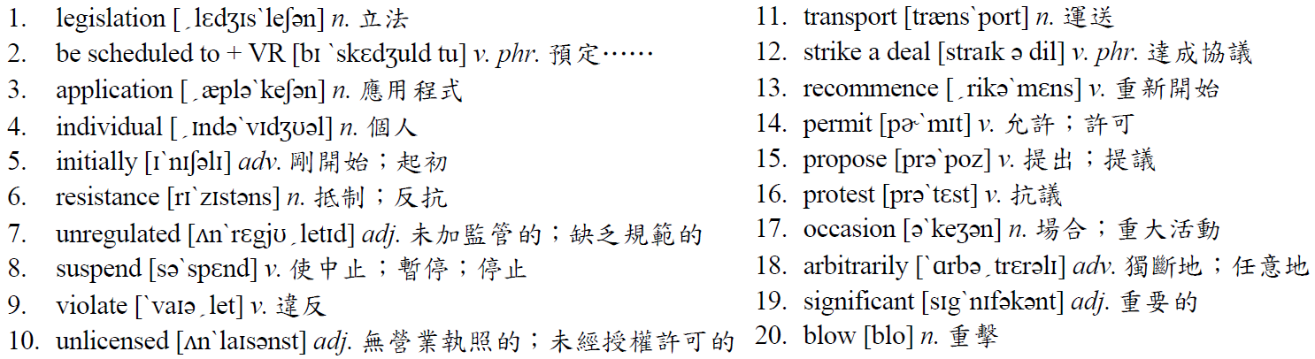

◆ Patterns
The new rules will change the way car rental companies operate, making it difficult, if not impossible, for Uber to continue offering its services.
句中的it為虛受詞，真正的受詞為to continue offering its services。在英文句子中，若受詞太長，而後面還會接補充說明受詞的補語時，就可以把受詞的位置先用虛受詞代替，而把真正的受詞移到後面。
‧I found it very time-consuming to make dumplings from scratch.
（我發現要從頭開始包水餃很費時。）
‧Many students consider it distracting to study and listen to music at the same time.
（許多學生認為同時讀書又聽音樂是會讓人分心的。）
◆ Translation
臺灣Uber危在旦夕
預
定在四月二十六日生效的新法令，可能讓在臺灣的共乘服務Uber劃下句點。在2013年中，這項使用一個應用程式來撮合有註冊的駕駛和在尋找搭車的人的服務，在臺灣首度營運。它遭遇到來自計程車司機和公司的抵抗，抱怨它是一個未經註冊且不受規範，會影響到他們生意的服務。Uber在2017年初，因無照經營運送服務違反高速公路法，而被迫暫停。然而，在和政府談妥，使它可以用租用汽車服務方式營運的條件後，Uber在兩個月後重新開始營運。
新的規定將會改變租車公司的營運方式，使得Uber如果不是不可能，就是很難繼續提供服務。不像計程車服務，以點對點的方式收費，它現在必須要以小時或以日計算費率收費。此外，駕駛將不被允許在城市繁忙的地區繞來繞去找尋乘客。
當這個新法令在二月被提出時，遭遇到很多Uber駕駛的反抗。他們有好幾次在交通部外面抗議。他們提出新法被提出得太突然，且武斷蠻橫，將影響到他們謀生養家的能力。Uber在臺灣十分普遍，有一萬名駕駛以及三百萬使用這項服務的乘客。根據這家公司所說，臺灣是他們在北亞最大的市場，而被迫停止營運會是重大的打擊。

◆ Answer
(1) A (2) B (3) D (4) B (5) C (6) A (7) D (8) B (9) A (10) B
Newscope 新聞瞭望臺 第九十四期

International News

Notre-Dame in Flames
P
aris, France’s Notre-Dame cathedral has suffered a devastating fire that did extensive damage to much of the 800-year-old building. The fire broke out shortly after 6 p.m. on April 15th. Although fire department officials had been called to scene, they failed to find any evidence of a fire. However, at approximately 6:45 p.m., security guards at the cathedral alerted authorities when they noticed flames raging in the wooden roof of the structure. By the time fire fighters arrived, the fire was out of control. It was eventually put out after nine difficult hours. Fortunately, nobody was killed in the blaze, though one fire fighter and two police officers were reportedly injured while battling the inferno. The exact cause of the fire is still under investigation, though there are suspicions that it may have been related to some renovation work that was being done.
Construction of Notre-Dame de Paris, or Our Lady of Paris, began in 1160 and took about one century to complete. It has long been one of the most iconic symbols of culture and religion in France and ranks among the nation’s top tourist attractions. While it has suffered damage due to various reasons over the years, it managed to survive both World Wars I and II largely unscathed. Because of the age of the structure, it has required constant maintenance at the cost of two million euros to the French government annually. Recent efforts to get large donations for a more complete restoration of the cathedral had not been very successful. However, after the devastating blaze, pledges of donations to rebuild the Paris landmark flooded in, reaching one billion euros within days.
Rebuilding Notre-Dame de Paris is expected to take about five years. Miraculously, the stone walls of the cathedral remained largely intact, and the beautiful stained glass North Rose Window was not damaged. The French government has assured the people of France and the world that the cathedral will be restored to its former glory.
◆ Multiple Choice
1. Which of the following statements about Notre-Dame de Paris is NOT true?
(A) It took around one hundred years for its builders to finish it.
(B) It suffered large amounts of damage during the World Wars.
(C) It receives funding from the government of France.
(D) It is one of the most-visited tourist sites in the entire country.
2. Which of the following pieces of information about the fire is NOT provided?
(A) The approximate time that the fire was discovered.
(B) The people who discovered the fire.
(C) The amount of time it took to extinguish the fire.
(D) The precise reason why the fire started.
3. What can the readers infer from the passage?
(A) The government of France will lead the efforts to rebuild the cathedral.
(B) The cathedral may look slightly different from its original design.
(C) The North Rose Window may have to be replaced.
(D) Most of the money to restore the cathedral will come from the French government.

 火災是常見的災害(disaster)，而起火的原因有很多，有可能是縱火(arson)、瓦斯外洩(gas leaks)、爆竹工廠(fireworks factory)不小心引發爆炸(explosion)或是電線走火(electrical wiring malfunction)等等。消防人員(fire fighter)在接到通報後會立即出動消防車(fire engine)，甚至是救護車(ambulance)以展開救援(rescue)。因此要特別注意的是路邊的消防栓(fire hydrant)旁是不可以停車的，因為這樣可能會阻礙到(impede)消防人員的救火任務。由於火災是可以預防的(preventable)，所以平時就應該要隨時保持環境通風，並審慎地遵守(obey)使用火的安全規範(safety guidelines)，才能避免災害的發生。
Before You Read
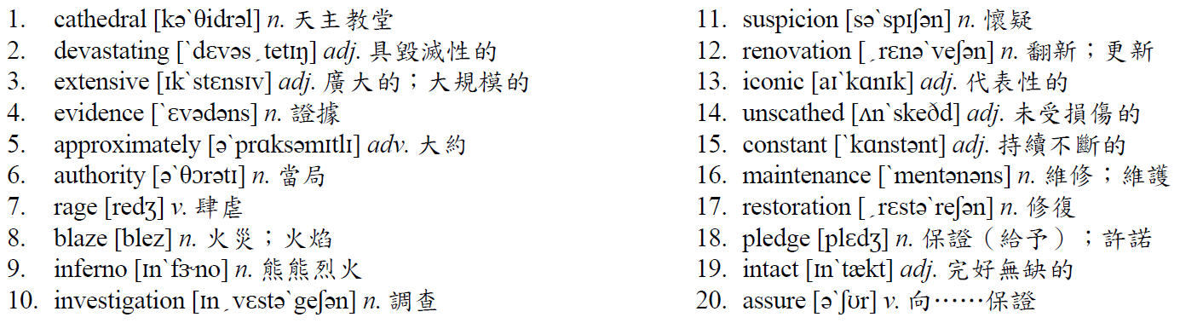
◆ Vocabulary and Idioms

◆ Patterns
Fortunately, nobody was killed in the blaze, though one fire fighter and two police officers were reportedly injured while battling the inferno.
本句為保留連接詞的分詞構句，while的後面省略they were。將句子改為分詞構句的基本步驟為：
1. 省略連接詞。2. 主詞相同時再將主詞省略。3. 動詞改為分詞，主動改為現在分詞，被動改為過去分詞。
但若連接詞被省略後會造成句意不清時，可將連接詞保留。例如可保留before、after等表時間先後的連接詞。
‧Before we have dinner every evening, my brother and I help set the table.
= Before having dinner…, my brother and I help…. （每天晚上吃晚餐之前，我和弟弟會幫忙擺設餐桌。）
‧After Jack was picked up at school in the car by his parents, he took a short nap on the way home.
= After being picked up…, Jack took…. （Jack在學校被爸媽開車接走後，會在回家的路上小睡片刻。）

◆ Translation

巴黎聖母院遭祝融之災
法
國巴黎的聖母院遭受到是使這座有八百年歷史建築受到大規模破壞、具毀滅性的祝融。這場火災是在四月十五日下午六點過後不久爆發的。雖然消防部門官員已經被叫到火災現場，但是他們還是無法找出火災的證據。不過約在下午6:45時，教堂的警衛人員注意到建築的木屋頂有火苗肆虐時，就通知有關當局。當消防人員到達時，火勢已經無法控制。在歷經艱難的九小時之後，火終於被撲滅。幸運的是，雖然據報導有一位消防員和兩位警官在對抗大火時受傷了，但沒有人在這場火災中喪生。雖然有人懷疑起火原因是在和正在進行的翻修工作有關，但是確切的起火原因仍在調查中。
巴黎聖母院的建造開始於西元1160年，且花了約一世紀的時間完成。它長久以來是法國文化和宗教最具代表性的象徵之一，而且是該國排名頂尖的旅遊景點。雖然多年來因為不同的原因遭受到破壞，卻成功地在第一次和第二次世界大戰中倖存，大部分都完好無缺。因為建築老舊，法國政府每年需花費兩百萬歐元持續不斷地維修。最近想取得捐款，來對該教堂進行更完善修復的工作一直不太成功。然而，在這場破壞性的大火後，來自各個公司和富有的人們的捐贈，以重建巴黎地標的承諾不斷湧入，幾天內已經達到十億歐元。
重建巴黎聖母院預期約要花五年的時間。神奇的是，該教堂的石牆大部分都仍然完好，而北面的玫瑰彩繪玻璃窗沒有被破壞。法國政府已向法國以及全世界的人們保證這座教堂將會回復從前的榮耀。

◆ Answer
(1) B (2) D (3) A

