

NEWSCOPE
發行人：李枝昌
執行編輯：蕭勝元
創刊日：2007年4月2日 出刊日：2019年3月15日
電話：(02)2298-2933 傳真：(02)2298-9766
發行所：龍騰文化事業股份有限公司
公司地址：248 新北市五股區五權七路1號
新聞瞭望臺 第九十三期 作者：洪孟萍 Angus James Bain

龍騰文化全球資訊網：http://www.lungteng.com.tw（本刊物同步刊載於龍騰文化全球資訊網，歡迎教師、同學下載）


National News

African Swine Flu Mars Year of the Pig
A
s many parts of Asia celebrated the Lunar New Year, tension grew between China and Taiwan regarding an outbreak of African swine flu. The disease was first identified in China’s Liaoning province in August of last year. Within a matter of months it had spread to over 20 other provinces, putting
(1) of the nation’s massive pig population in jeopardy. While not dangerous to humans, African swine flu is (2) to pigs and boars. To date, close to one million pigs have been culled in an attempt to
(3) the spread of the disease. According to Chinese and UN authorities, the epidemic is now under control, (4) it could take years before the disease is eradicated.
In order to (5) its own US$2.5 billion pork industry, Taiwanese authorities have banned the importation of pork products for years. In light of the (6) outbreak in China, the fine for bringing pork products into the country was first raised from NT$15,000 to NT$50,000, and then to NT$200,000 in December. Repeat offenders, however, may (7) a penalty of up to NT$1,000,000. (8) these fines and multiple warnings to international travelers going to Taiwan, there have been hundreds of cases of people being caught with banned pork products at major airports in the country.
(9) concerns about the vulnerability of Taiwan’s pork industry were raised when an infected pig carcass from China washed up on the island of Kinmen. A (10) by Taiwanese authorities for information on the pig went unanswered by China, prompting the Taiwanese government to criticize China for not being transparent about the extent of the epidemic. According to critics of the Chinese government, it has a long history of trying to cover up or conceal serious outbreaks of disease.
Cloze
(A) protect (B) much (C) despite (D) major (E) although
(F) stop (G) recent (H) request (I) deadly (J) face
(1) (2) (3) (4) (5) 1
(6) (7) (8) (9) (10) 1

 人們常常會聽到各式各樣的傳染病（infectious diseases）、引發傳染病的病毒（virus）或細菌（germ; bacteria），有時有疫苗（vaccine）可供使用，但有時沒有。不過我們必須了解到，疫苗接種（vaccination）並不代表可以停止疾病的傳播，我們最該做的就是對傳染病有正確的觀念（notion），並且要加強自身的免疫力（immunity），注意飲食（diet）、保持運動及良好衛生（hygiene）習慣。

Before You Read

◆ Vocabulary and Idioms
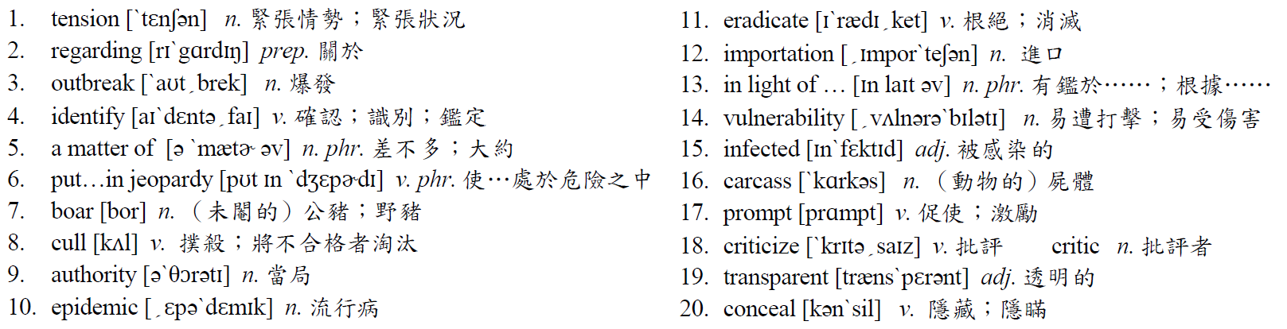

◆ Patterns
In order to protect its own US$2.5 billion pork industry, Taiwanese authorities have banned the importation of pork products for years.
當 to + V 出現在句首時，情況有兩種：一種是以不定詞作為主詞，此時後面所接的動詞必須用單數動詞。另一種是省略掉 in order而來的不定詞片語，表示「為了……」的意思。
‧To say is one thing; to do is another.
（說是一回事，做又是另一回事。）
‧To achieve her goal, the scientist has buried herself in her experiments day and night.
（為了達到她的目標，這位科學家日以繼夜地埋首於實驗當中。）
◆ Translation
非洲豬瘟讓豬年蒙上陰影
當
亞洲的許多地方正在慶祝的農曆新年的時候，中國和臺灣之間因為非洲豬瘟的爆發而緊張情勢加溫。這個疾病剛開始是在去年八月中國的遼寧省被確認的。在差不多幾個月之內，已經散播到超過其他二十多個省份，讓這個國家大規模的豬隻處於危險當中。雖然對於人類並沒有危險，非洲豬瘟對於豬和野豬來說是致命的。到目前為止，為了要阻止這場疾病的擴散，有近一百萬頭的豬已被撲殺。根據中國和聯合國當局，這項流行病目前為止已經在控制當中，雖然在它完全根絕之前可能還要經過好幾年。
為了要保護約二十五億美元的豬肉業，臺灣當局已經禁止豬肉產品的進口好多年了。有鑑於最近在中國的疫情爆發，對於將豬肉產品帶進國內的罰金已經先從一萬五千元臺幣提高到五萬元，然後在十二月又提高至二十萬元。不過，累犯者可能會面臨高達一百萬元的罰款。儘管有這些罰金，以及對於來到臺灣的國際旅遊者的許多警告，在國內的幾個主要機場中，仍然有數百件關於人們被抓到帶有禁止攜入的豬肉產品案例。
引發臺灣豬肉業打擊的主要擔憂，是有被感染的豬隻屍體從中國被沖到金門島外。中國對於臺灣當局所提的關於豬隻訊息的要求，並沒有任何的回應，而這使得臺灣政府批評中國，對於疫情掌握程度不透明。根據中國政府的批評者所說，中國長久習於試著掩蓋，或者是隱瞞重大疾病的爆發。

◆ Answer
(1) B (2) I (3) F (4) E (5) A (6) G (7) J (8) C (9) D (10) H
Newscope 新聞瞭望臺 第九十三期

International News

Extreme Cold Paralyzes Parts of the United States
I
n what has been described by meteorologists as a once-in-a-generation weather event, large areas of the US were hit by an extreme cold snap that brought record low temperatures. Beginning in late January and moving into February, the storm caused schools, government offices and business to shut down. More seriously, it led to hundreds of cases of frostbite and the deaths of over two dozen people. It is estimated that around 250 million people in the US were affected by the unusually cold temperatures, 90 million of whom experienced temperatures below -17˚C.
The storm was attributed to the polar vortex, a stream of cold air that circulates around the North Pole, descending into the continental United States. Climate scientists believe that warmer ocean water and warmer temperatures in the Arctic caused the polar vortex to dip to the south, bringing frigid air with it. The states of the Midwest bore the brunt of the storm, with the lowest temperatures being recorded in Minnesota at almost -50˚C. Major cities including Chicago, Detroit, Milwaukee and Detroit hit record or near-record lows. People in many areas were cautioned against going outdoors. Despite these warnings, more than 20 people died from the cold. Accounts of the deaths included victims who collapsed while clearing snow, victims who were unable to find shelter before succumbing to the cold, and even victims who froze to death in unheated homes.
Some climate change deniers have used the polar vortex to support their view that global warming is either not really happening or is not as big a problem as many think. However, climate scientists strongly disagree, claiming that extreme weather events like the polar vortex in winter or super typhoons and hurricanes in the warmer months are a direct result of warmer ocean waters. If this is indeed the case, people in vulnerable areas will have to prepare themselves for more weather like this in the future.
◆ Multiple Choice
1. According to the passage, which of the following statements is TRUE?
(A) The storm caused by the polar vortex resulted in hundreds of people dying.
(B) Most American had to suffer through temperatures under -17˚C.
(C) The storm was at its worst in the Midwestern states of the US.
(D) The coldest temperatures that were recorded were under -50˚C.
2. According to the passage, what warning was given to people?
(A) They were warned not to clear snow.
(B) They were warned to wear warm clothing.
(C) They were warned to keep their home heated.
(D) They were warned to stay inside their homes.
3. What can the reader infer from the passage?
(A) Extreme weather events like the polar vortex may help to slow down global warming.
(B) Extreme weather events like the polar vortex may become more common in the future.
(C) The polar vortex is a more serious climate issue than super typhoons and hurricanes.
(D) Warmer ocean waters may cause people to die at the North Pole.

 全世界各地偶爾會遭受到天災（natural disaster）的襲擊。在臺灣常見的天災有颱風（typhoon）、泥流（mudslide）、水災（flood）、土石流（landslide）以及地震（earthquake）等。其他常發生的天災則有龍捲風（tornado）、暴風雪（blizzard）、火山爆發（volcanic eruption）等等。有些天災可以預測（predictable）而有些則無法預測（unpredictable）。不管如何，當知道天災即將發生時，做好預防措施（take precautions），就可以將死傷人數（casualty）降到和破壞（damage）程度降到最低。
Before You Read
◆ Vocabulary and Idioms
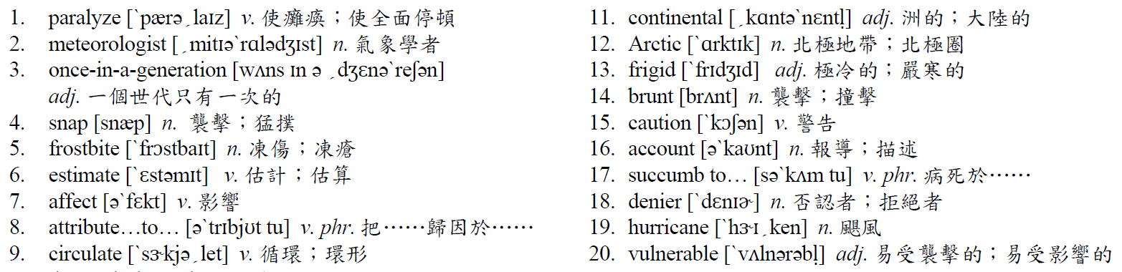

◆ Patterns
Despite these warnings, more than 20 people died from the cold.
= In spite of these warnings, more than 20 people died from the cold.
despite和in spite of表「儘管」，分別為介系詞及介系詞片語，後面只能接名詞作為其受詞。若接動詞時，則須改為動名詞，若要接一完整子句，則可以 In spite of the fact that + S + V表示。
‧Despite the heavy snow outside, the kids still went out to play.
= In spite of the heavy snow outside, the kids still went out to play.
= Despite the fact that it was heavily snowing outside, the kids still went out to play.
= Although it was heavily snowing outside, the kids still went out to play.
（儘管外面下著大雪，孩子們仍然出去玩。）

◆ Translation

極度低溫癱瘓美國部分城市
美
國大部分地區遭受破紀錄極度低溫襲擊，而這樣的天氣狀況，被氣象學家描述為一個世代只有一次，從一月底開始一直進入到二月，這場風暴造成學校、政府機關和各個行業停業。更嚴重的是，它導致了數百個凍傷的案例以及二十多起死亡。據估計，在美國大約有二億五千萬人受到這異常低溫的影響，而當中有九千萬人經歷零下十七度以下的溫度。
這場低溫風暴是由極地渦漩所導致，它是一道在北極地區循環，下降至美國大陸的冷空氣。氣候科學家相信在北極圈較溫暖的海水，以及較溫暖的氣溫造成極地氣旋，而沿途挾帶著極冷的空氣，往南方下降。美國中西部各州必須忍受這在明尼蘇達州記錄到最低溫約零下五十度風暴的襲擊。包括芝加哥、底特律、密爾瓦基和底特律溫度也都破紀錄或接近最低溫紀錄。許多地區的人們被警告不要到戶外去。儘管有這些警告，仍然有二十多人死於低溫。有關死者的報導，包括在鏟雪中昏倒的、在找到躲避處之前就冷死的、還有在沒有暖氣的家中活活冷死的。
有一些否認氣候變遷的人，一直用極地渦漩來支持他們的觀點：他們認為全球暖化並沒有真正在發生，或不像許多人所認為那麼嚴重。然而，氣候科學家們強烈反對，宣稱極度天氣的情況，像是在冬天的極地渦漩或在較溫暖月分中的超級颱風或颶風，就是海水溫度升高的直接結果。如果情況的確是如此，在這易受到襲擊地區人們，必須為未來有更多像這樣的天氣做好準備。

◆ Answer
(1) C (2) D (3) B

