
NEWSCOPE
發行人：李枝昌
責任編輯：劉育如
創刊日：2007年4月2日 出刊日：2011年9月30日
電話：(02)2299-9063 傳真：(02)2299-5311
發行所：龍騰文化事業股份有限公司
公司地址：248 新北市五股區五權七路1號
新聞瞭望臺 第六十二期 作者：洪孟萍 Angus James Bain

龍騰文化全球資訊網：http://www.lungteng.com.tw（本刊物同步刊載於龍騰文化全球資訊網，歡迎教師、同學下載）


National News

Doctors Transplant HIV-Positive Organs
I
n a shocking example of (1) can go wrong when proper procedures are not followed, the organs of an HIV positive donor were transplanted into five unsuspecting patients. Perhaps even more shocking is the fact (2) the blunder took place at National Taiwan University Hospital (NTUH), the top research and teaching hospital in the nation. According to hospital officials, the mistake (3) a misunderstanding between two individuals responsible for checking the medical status of the organ donor. Hospital protocol demands that the health status of a donor be checked by computer prior to any procedure taking place. In this situation, (4) , a simple phone call was made. The official representing the transplant team apparently misunderstood that the donor was HIV negative (5) HIV positive. Nobody on the transplant team bothered to verify the test results, and the procedure went ahead as scheduled,
(6) the infected organs. Critics point to a systemic failure in following procedures at the hospital and claim that the unfortunate incident (7) easily avoided if the people involved had done their job properly.
Each year in Taiwan, tens of thousands of people are harmed (8) mistakes made by doctors, nurses, and other medical technicians during the course of treatment. In this situation, the repercussions of the medical error are likely to be very dire indeed. The patients who received the infected organs will not know until early next year (9) they have been infected with the deadly HIV virus. (10) the medical staff involved in the fiasco, the head of the NTUH organ transplant task force has resigned, and the doctors who took part in the procedures could face up to a decade in prison due to their negligence.
◆ Cloze
1. (A) which (B) what (C) when (D) it
2. (A) that (B) which (C) where (D) when
3. (A) resulted from (B) resulted in (C) led to (D) pointed out
4. (A) meanwhile (B) on the other hand (C) though (D) in contrast
5. (A) opposite to (B) instead (C) but (D) rather than
6. (A) which was used (B) in using (C) used (D) using
7. (A) should have been (B) should be (C) could have been (D) could be
8. (A) in (B) due to (C) for (D) when
9. (A) how (B) while (C) when (D) if
10. (A) As for (B) According to (C) With (D) Reported by

根據性傾向（sexual orientation）的不同，我們常聽到有男同性戀（gay），女同性戀（lesbian），以及雙性戀（bisexual）以及異性戀（heterosexual）這樣的詞語。對於同性戀者對外公布自己的性別傾向，稱之為出櫃（come out of the closet）。性傾向為何，都應予以尊重（respect），更應注意不該用不當（inappropriate）或有侮辱性的（insulting）字詞來稱呼他人。

Before You Read

◆ Vocabulary and Idioms

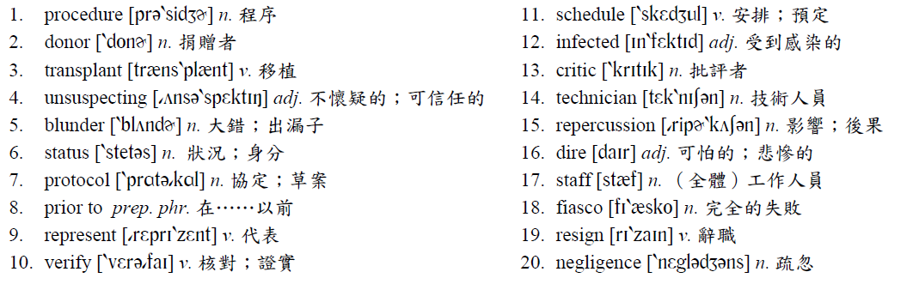

◆ Patterns
Critics point to a systemic failure in following procedures at the hospital and claim that the unfortunate incident could have been easily avoided if the people involved had done their job properly.
could have + p.p.常出現在以下兩種情況：
1. 表示過去有能力做某事卻沒有做：
．You could have caught the first bus if you hadn’t slept in this morning.
（今天早上你要是沒有睡過頭的話，就可以趕上第一班公車。）
2. 推測過去可能會發生但卻沒有發生的事：
．You could have been run over by the truck if you hadn’t stopped then.
（你當時要是沒有停下來的話，就可能會被這輛卡車輾過。）

◆ Translation

醫師移植HIV陽性患者器官
當
沒有遵循正確的程序而可能會出差錯的一個令人震驚的例子中，一位HIV陽性反應器官捐贈者的器官被移植到五位不疑有他的病患身上。也許更令人震驚的是這個大錯竟是發生在國內頂尖研究及教學醫院──臺大醫院。根據醫院職員指出，這項錯誤是因為兩位負責確認器官捐贈者病況之間的誤會所造成。醫院的規定要求捐贈者的健康狀況必須在任何一項程序進行之前用電腦檢視過。然而，在這個案例中，竟只是以一通簡單的電話通話完成。移植工作小組的代表顯然誤會了這個捐贈者是HIV陰性而非陽性。移植工作小組竟懶得去核對測試的結果，而移植的程序就按既定計劃進行，使用了受到感染的器官。批評者指向醫院在遵循程序時一個系統上的失敗，並表示如果參與該項工作的人確實做好他們的工作，這項不幸的事件可以輕易地避免。
在臺灣每一年都有數萬人因為醫師、護士和其他醫療技術人員在治療的過程中所犯的錯誤而受到傷害。在這次的案例中，這項醫療疏失所造成的後果實際上可能會是很可怕的。那些接受感染器官的病人要到明年初才能知道他們是否感染到致命的HIV病毒。至於與這項任務失敗有關的醫療工作人員，臺大醫院器官移植小組召集人已經辭職，而那些參與過程的醫師們可能會因為他們的疏忽而面臨長達十年的牢獄之災。

◆ Answer
(1) B (2) A (3) A (4) C (5) D (6) D (7) C (8) B (9) D (10) A
Newscope 新聞瞭望臺 第六十二期

International News

Libyan Dictator Deposed
fter more than forty years as the leader of Libya, Muammar Gaddafi has been removed from power following a bloody civil war. The war, which began in mid-February of this year, pitted rebel forces opposed to his rule against police and military units which were loyal to the dictator. Forces on each side struggled for months to gain the upper hand. With the support of NATO aircraft, however, the tide of the war finally turned in favor of the rebels, and in August they were able to capture the capital city of Tripoli and gain control of the country. Gaddafi was forced to flee, and while his whereabouts are still unknown, he is wanted by both domestic and international authorities for crimes against humanity.
A
Muammar Gaddafi came to power in 1969 as the leader of a group of military officers that deposed the country’s monarch, King Idris. During the following decade, Gaddafi solidified his hold on power by crushing any dissent to his rule and imprisoning or executing political opponents and critics. In the latter part of the decade, he began building up the Libyan military and used much of the nation’s oil wealth to buy weapons. By the mid-1980s, Gaddafi had been alienated from much of the world due to his radical anti-Western views and his sponsorship of terrorist acts abroad. In the past decade, however, his views had softened somewhat, and he sought acceptance in the international community.
Any chance of reconciliation, however, has ended with his ouster. In addition to the human rights abuses that Gaddafi is accused of, his critics claim that he and his friends and family lived a life of luxury while the majority of the Libyan people suffered high unemployment and poverty. They promise that the man and his supporters will be brought to justice and made to pay for their actions.
◆ Multiple Choices
1. According to the passage, which of the following is true?
(A) Gaddafi’s forces were aided by NATO warplanes.
(B) Gaddafi was the leader of Libya since the mid-1980s.
(C) Gaddafi was on friendly terms with Western nations.
(D) Gaddafi had a role in international terrorism.
2. What is meant by the word ouster?
(A) Retirement. (B) Stepping down. (C) Forcing out. (D) Support.
3. What cannot be inferred from the passage?
(A) Libya makes money from the sale of oil.
(B) Libya’s former King was a good friend of Gaddafi’s.
(C) Gaddafi is a man who doesn’t believe in democracy.
(D) Libya has been responsible for terrorism in other countries.

常見的一些世界性機構或組織的英文縮寫有以下幾個：
WHO：World Health Organization 世界衛生組織
WTO：World Trade Organization 世界貿易組織
GATT：General Agreement on Tariffs and Trade 關稅暨貿易總協定
UNESCO：United Nations Educational, Scientific and Cultural Organization 聯合國教科文組織
NATO：North Atlantic Treaty Organization 北大西洋公約組織
BRICS：Brazil, Russia, India, China, South Africa 金磚五國
Before You Read

◆ Vocabulary and Idioms
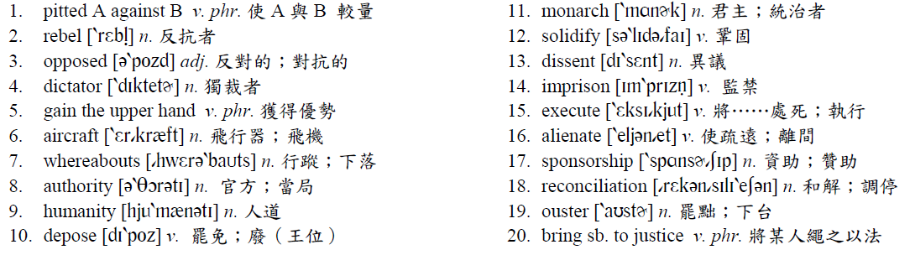

◆ Patterns
1. Gaddafi was forced to flee, and while his whereabouts are still unknown, he is wanted by both domestic and international authorities for crimes against humanity.
2. In addition to the human rights abuses that Gaddafi is accused of, his critics claim that he and his friends and family lived a life of luxury while the majority of the Libyan people suffered high unemployment and poverty.
while 常見的用法：
1. 表「而」：
．When it comes to movies, girls tend to like romantic ones while boys usually prefer action movies.
（當談到電影時，女生往往喜歡文藝片而男生通常較喜歡動作片。）
2. 表「當……」：
．The doorbell rang while I was studying upstairs late last night.（昨晚深夜，當我在樓上讀書時，門鈴響了。）
3. 表「雖然」：
．While the criminal was still at large, the police claimed they would bring him to justice before long.
（雖然這位罪犯仍然在逃，警方聲稱不久之後就會將他繩之以法。）
◆ Translation
利比亞狂人下臺
在
一場血腥的內戰之後，身為利比亞領袖逾四十年的穆阿邁爾．格達費，政權已經瓦解。這場在今年二月中開始的戰爭，使得反對他統治的反叛軍與對這位獨裁者忠心耿耿的軍警單位互相較量。雙方的武力幾個月來努力的想要占上風。然而，有北大西洋公約組織的空軍支持，反叛軍逐漸占了上風，而在八月他們能夠攻占首都黎波里，並控制整個國家。格達費被迫逃亡，且雖然他的行蹤仍然不明，國內以及國際間反對人權犯罪組織都想找到他。
格達費在一九六九年成為一群罷免該國國王伊德里斯一世的軍官領導者，因而取得了權力。在接下來的十年裡，格達費藉由粉碎對他統治的異議，以及將反對者及批評者監禁和處死的方式來鞏固其政權。在該十年的後半時期，他開始建立利比亞軍隊，而且將該國大部分的石油財富拿來買武器。到了一九八○年中期，格達費已經被世界大部分國家所疏離，因為他激進的反西方世界觀點以及對國外恐怖行動的資助。不過在過去的這十年來，他的看法已有些微軟化，而且他也尋求國際社會的接受。
然而，任何一個和解調停的機會已經隨著他的下台而結束。除了被指控他對於人權的侵犯外，他的批評者聲稱，當大部分利比亞人民遭受極高的失業率及貧窮所苦時，他和他的親友們卻過著奢華的生活。他們承諾格達費以及他的支持者將會被繩之以法，並且為他們的所作所為付出代價。

◆ Answer
(1) D (2) C (3) B

