
NEWSCOPE
發行人：李枝昌
執行編輯：翁維隆
創刊日：2007年4月2日 出刊日：2018年12月14日
電話：(02)2298-2933 傳真：(02)2298-9766
發行所：龍騰文化事業股份有限公司
公司地址：248 新北市五股區五權七路1號
新聞瞭望臺 第九十二期 作者：洪孟萍 Angus James Bain

電子檔網址：https://ltn.tw/eVsPs5e（本刊物同步刊載於龍騰文化全球資訊網，歡迎教師、同學下載）


National News

Scores Dead and Injured in Taiwan Train Derailment
aiwan’s worst rail disaster in more than a quarter of a century resulted in eighteen deaths and over two hundred injuries when a Puyuma express train bound for Taitung derailed in Yilan County. (1) The Ministry of Transport has identified excessive speed and driver error as the direct causes of the accident.
T
The train had left New Taipei City’s Shulin station shortly before 3 p.m. on October 21 and had been traveling southbound for two hours when the incident occurred. (2) According to witnesses both inside the train and on the ground, loud noises, sparks, and smoke came from the train before it crashed. The derailment resulted in all eight cars of the train leaving the tracks, with four of them rolling over onto their sides. (3) Some passengers were able to smash through the windows of the train and escape while others were rescued by emergency responders who arrived on scene shortly after the derailment. (4) 1
Investigators were quick to lay the blame on the driver of the train. They claimed he had disabled the automatic train protection (ATP) system, which regulates the train’s maximum speed. (5) It remains to be seen what the outcome of the investigation will be and what consequences the driver may face.
◆ Discourse Structure
(A) Investigators established that the train had been traveling at 140 km/h when it entered a relatively tight curve which had a maximum speed limit of 80 km/h.
(B) The majority of people who suffered major injuries were in these cars.
(C) The derailment occurred on a curved section of track as the train was traveling past Xinma station.
(D) Efforts to locate and rescue the survivors who were still trapped in the wreckage continued into the late afternoon and evening.
(E) However, he claimed he had done this because he had been ordered to make up a fourteen-minute delay that had been caused by a mechanical problem earlier in the journey.
(1) (2) (3) (4) (5) 1

 不論是在市區(downtown)、郊區(suburb)或是高速公路(highway)上，經常可看到車禍(car accident; car crash)發生。而常見的車禍原因(cause)有很多，可能是駕駛人無照駕駛(driving without a valid driving license)、超速(speeding)、酒駕(drunk driving)、疲勞 (fatigue)或是違反交通法規(traffic regulation)等。而在車禍現場常可看到警方人員架起路障(roadblock)，以調查原因，以及醫療人員(paramedic)照護傷者或將其送往醫院進行治療(treatment)，當然也會有一些圍觀者(onlooker)。不論如何，遵守交通規則，小心駕駛，才能避免意外發生。

Before You Read

◆ Vocabulary and Idioms
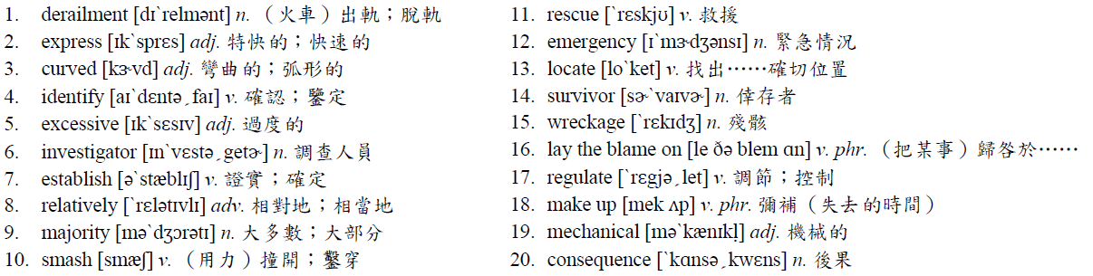

◆ Patterns
Some passengers were able to smash through the windows of the train and escape while others were rescued by emergency responders who arrived on scene shortly after the derailment.
Some… some/others… (still others…)：表示「有些……，有些……，（還有一些……）」，用於某數量多且無固定範圍的群體。
‧ My classmates have different plans for this summer. Some will join camps, others will do volunteer work, and still others will go traveling with their family.
（我的同學今年暑假有不同的計畫。有些要去營隊，有些要去當志工，而有些要和家人去旅行。）
Some of the… the others…：表示「有些……，其它的……」，用於有限定範圍的群體，且僅可分作兩類。
‧Some of the flowers here are roses, and the others are daisies. Which kind do you prefer?
（這些花當中有一些是玫瑰，其餘的是雛菊。你比較喜歡哪一種?）

◆ Translation
臺灣火車出軌事件造成數百人傷亡
前
往臺東的普悠瑪特快車在宜蘭縣脫軌，造成十八人死亡以及超過兩百人受傷，成為超過四分之一世紀以來，臺灣最嚴重的火車災難。這個脫軌發生在火車行駛通過新馬站時的一個急轉彎處。交通部已經證實超速以及駕駛過失是這次意外直接的肇因。
火車在十月二十一日下午接近三點時，離開新北市的樹林站，而當事件發生時，它已經往南行駛兩小時了。調查人員證實當火車進入一個相對彎曲且每小時最高限速八十公里的彎道時，是以時速一百四十公里行駛。根據火車內以及地面上的目擊者所說，在火車撞毀前，從火車裡傳出了巨大聲響、火星和煙。這起脫軌事件導致火車所有八節車廂脫軌，而其中有四節翻覆，倒向側邊。大部分受重傷的人都在這幾節車廂內。有些乘客能夠用力撞開火車的窗戶並且逃離，而其他人則被火車脫軌後不久到達現場的緊急救難人員救出。找到並且救出仍然被困在殘骸中的生存者救援工作，一直持續到傍晚和夜晚。
調查人員很快將疏失歸咎於火車的駕駛。他們聲稱，他關閉了控制火車最高限速的列車自動保護系統。然而，他聲稱他這麼做，是他被命令要彌補因為這趟旅程中早些時候，因機械問題所導致的十四分鐘延誤。調查的結果為何，以及駕駛可能會面對什麼樣的後果仍然有待觀察。

◆ Answer
(1) C (2) A (3) B (4) D (5) E
Newscope 新聞瞭望臺 第九十二期

International News

Historic Tokyo Fish Market Shuts Down
A
fter more than eighty years, Tokyo’s famous Tsukiji fish market has closed its doors. The iconic market was not only the largest of its kind in the world but also served as a major tourist attraction in the Japanese capital. The market’s operations have been moved to the Toyosu district of Tokyo, and there are plans to redevelop large parts of the area where the original market stood.
The Tsukiji fish market’s origins go back almost a century. In 1923, a massive earthquake destroyed much of the city’s previous main fish market in the district of Nihonbashi. Later, construction of the Tsukiji fish market commenced, involving well over 400,000 workers. After more than six years of construction, the market finally opened for business in early 1935. Between then and October of 2018 when it closed, the market bustled with activity almost every day as traders bought and sold a wide range of seafood products. Seafood auctions began shortly after 5:00 a.m., with around 1,500 tons of products being bought and sold on an average day. Handling all of this business required a workforce of around 60,000 people.
Over the years, the market became more than simply a place for fishermen and seafood traders to buy and sell their goods; it also became one of the hottest tourist spots in the city, drawing thousands of visitors each day. In fact, tourism played a role in the market being moved. For years, the fish traders in the market had complained about the throngs of tourists getting in their way while they were going about their work. The daily early morning fish auction had become such a popular attraction that the number of tourists permitted to watch it was eventually limited to just 120. The new Toyosu fish market, on the other hand, was designed with tourists in mind. It enables visitors to take in all the action of the market without getting in anybody’s way.
◆ Multiple Choice
1. From the passage, what do we know about the Tsukiji fish market?
(A) It was in operation for almost ten decades.
(B) It was established as a tourist attraction.
(C) It was the biggest fish market in the world.
(D) It was not open to tourists until very recently.
2. According to the passage, which of the following statements is true?
(A) The Tsukiji fish market first opened for business in 1923.
(B) It took around 60,000 people to build the Tsukiji fish market.
(C) The seafood auctions at the Tsukiji fish market started in the late afternoon.
(D) It took more than six years to build the Tsukiji fish market.
3. According to the passage, how is the new Toyosu fish market different from the Tsukiji fish market?
(A) Tourism was taken into account by its designers.
(B) It is located outside of the nation’s capital city.
(C) It is much smaller than the Tsukiji fish market.
(D) Tourists are much more restricted than at the Tsukiji market.

 在臺灣除了有外國遊客必造訪的夜市(night market)外，傳統市場(traditional market; wet market)更能夠表現出臺灣傳統的文化(culture)。因為在傳統市場中，到處可聽到攤販(vendor)的叫賣(peddling)聲，顧客(customer)的殺價(bargain)聲，以及熟識者(acquaintance)的閒聊聲。最棒的是，每個攤位相距不遠，想要找的食物和雜貨(grocery)，都可以在此買到。因此，儘管便利超商(convenience store)以及超級市場(supermarket)提供了更多便利的選擇(option)，許多人還是喜歡到傳統市場，去感受充滿人情味的氣氛(ambience; atmosphere)。
Before You Read
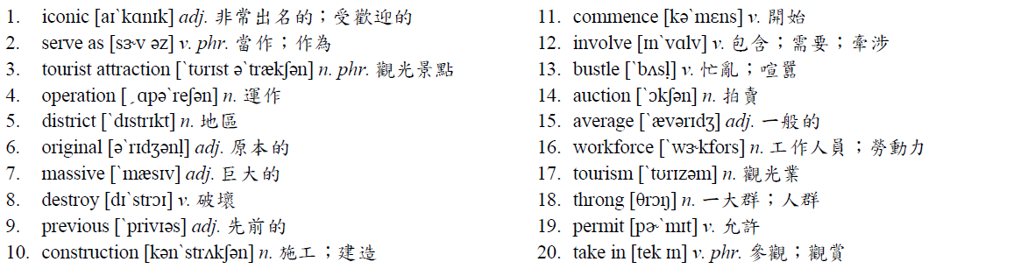
◆ Vocabulary and Idioms

◆ Patterns
The daily early morning fish auction had become such a popular attraction that the number of tourists permitted to watch it was eventually limited to just 120.
本句為such + N + that…或so + adj./adv. + that…的句型，意思為「如此……以致於……」。兩者最大的不同是，such是形容詞，後接名詞；而so為副詞，後接形容詞或副詞，而當such, so調到句首時，句子需倒裝。
‧Jack is such a great musician that the tickets to his concerts are always sold out.
= Such a great musician is Jack that the tickets to his concerts are always sold out.
（Jack是一位如此傑出的音樂家，以致於他的音樂會門票總是售罄。）
‧The man won so much money in the lottery that he screamed with excitement.
= So much money did the man win in the lottery that he screamed with excitement.
（這個男人贏得這麼多樂透的錢，以致於他興奮地尖叫。）

◆ Translation

具歷史意義的東京魚市場熄燈
在
八十多年之後，東京著名的築地魚市場劃下了句點。這個知名的市場不僅是世界上最大的魚市場，也是日本首都主要的觀光景點。這個魚市場的營運已經被移到東京的豐洲地區，而在原本市場所在的地區，將有再開發更大區域的計畫。
築地魚市場的起源可追溯回近一世紀以前。在1923年，一個大地震摧毁了這個城市之前在日本橋地區主要魚市場的大部分場地。後來，包含超過四十萬工人的築地魚市場興建工程開始。在超過六年的興建之後，這個市場終於在1935年初開幕營業。在那時和2018年十月關閉的這段期間，這個魚市場幾乎每天都是喧囂熱絡的，有商人買賣各式各樣的海鮮產品。海鮮拍賣在早上五點過後不久開始，平均每天有大約一千五百公噸的產品買賣。處理這些買賣大約需要六萬名工作人員。
這麼多年來，這個市場對於漁夫和海鮮商人而言，不僅是一個買和賣他們商品的地方；它也成為這個城市最熱門的旅遊景點之一，每天吸引數千名的訪客。事實上，觀光業在這個市場的遷移當中扮演一個重要的角色。市場裡的魚販們，多年來抱怨大群的遊客在他們工作時會干擾他們。而每天凌晨的魚貨拍賣，已經成為如此受歡迎的景點，以致於被允許來看拍賣的人數最後被限制到只有一百二十人。另一方面，新的豐洲魚市，設計時有將觀光客列入考慮。它可以讓遊客們觀賞魚市場的所有活動，而不會干擾到任何人。

◆ Answer
(1) C (2) D (3) A

