

NEWSCOPE
發行人：李枝昌
執行編輯：蕭勝元
創刊日：2007年4月2日 出刊日：2018年10月15日
電話：(02)2298-2933 傳真：(02)2298-9766
發行所：龍騰文化事業股份有限公司
公司地址：248 新北市五股區五權七路1號
新聞瞭望臺 第九十一期 作者：洪孟萍 Angus James Bain

龍騰文化全球資訊網：http://www.lungteng.com.tw（本刊物同步刊載於龍騰文化全球資訊網，歡迎教師、同學下載）


National News

Taiwanese Tourist Killed in Africa
T
ragedy struck a pair of Taiwanese tourists in Kenya when they were attacked by a hippopotamus. 66 year-old Chang Ming-Chuan was killed in the incident while his 62 year-old companion, Wu Peng-Te, (1) with only minor injuries. According to witnesses at the scene, the two men had been following a hippo along the shore of Lake Naivasha, taking photographs. When Mr. Chang came too (2) to the animal, it lunged at him, (2) him in the chest with its massive teeth. Bystanders quickly notified emergency services (3) the attack, and a medical team arrived to take the two men to a local hospital. While Mr. Wu suffered bruises in the attack, the wounds to Mr. Chang’s chest were so severe and caused so much blood loss (4) he did not survive. Following the incident, Kenyan authorities initially misidentified the two men (5) Chinese nationals. However, the Taiwanese Ministry of Foreign Affairs later clarified that they were from Taiwan and dispatched officials to (6) the matter. Kenyan wildlife officials later (7) the hippo and killed it.
While hippos may (8) gentle giants to many, they are actually among the most dangerous animals in Africa. They are fiercely territorial and will not hesitate to attack if they (9) . By some accounts, they are the deadliest large animal on the continent, responsible for hundreds of deaths annually, many times more than lions. With sharp teeth that can grow as long as 50 centimeters and the ability to outrun humans over short distances (10) their massive size and weight, they should never be approached. Unfortunately, however, it would seem that some tourists who venture into their territory are unaware of these frightening statistics.
◆ Multiple Choice
1. (A) to escape (B) escaped (C) escaping (D) who was escaped
2. (A) close; bitten (B) close; biting (C) closely; bitten (D) closely; biting
3. (A) of (B) by (C) for (D) with
4. (A) which (B) it (C) that (D) where
5. (A) about (B) by (C) for (D) as
6. (A) care for (B) be charged with (C) dispose of (D) deal with
7. (A) brought in (B) took in (C) tracked down (D) put down
8. (A) pretend (B) seem like (C) appear (D) serve as
9. (A) feel threatened (B) feel threatening (C) feel like threatening (D) feel like threat
10. (A) regarding (B) resulting in (C) due to (D) despite

 肯亞是狩獵旅行（safari）最受歡迎的目的地（destination）之一。在這裡遊客（tourist）有機會親眼目睹（witness）一年一度的牛羚大遷徙（annual wildebeest migration）。當然還可以和許多大型野生動物（big game）做近距離的接觸。要注意的是，如果是參加狩獵旅行，要特別留意隨身攜帶的行李（luggage）。有些顏色太鮮艷；或是黑色、藍色的衣服，並不適合（inappropriate）。因為可能容易吸引野生動物的注意，或引來導致傳染病（contagious disease）的昆蟲。在前往狩獵旅行的目的地之前，再三確認自己的行李是否恰當，是非常重要的。

Before You Read

◆ Vocabulary and Idioms

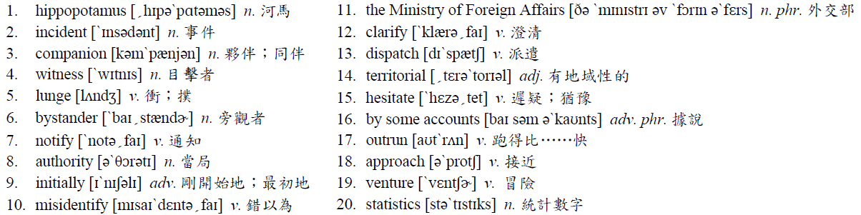 Patterns
By some accounts, they are the deadliest large animal on the continent, responsible for hundreds of deaths annually, many times more than lions.
形容詞或副詞的最高級，會出現含有三個或以上的人、事、物、地比較之中，以及比較對象很明顯地超出三個以上的地方副詞。
‧Michael is the most diligent student in his class.
（Michael是他班上最勤奮的學生。）
‧Of the four main courses to choose from, the steak is the most delicious.
（在供選擇的這四道主菜中，牛排是最美味的。）
‧Jason was the shortest among the eight runners, but he ran the fastest.
（Jason是八位跑者中最矮的，但他跑得最快。）
◆ Translation
臺灣遊客命喪非洲
兩
位在肯亞的臺灣遊客遭受了被河馬攻擊的悲劇。六十六歲的張明川在這起攻擊事件中喪命，而與他同行的六十二歲夥伴吳鵬德安全逃生，僅受了傷。根據在場的目擊者們指出，這兩個人一直沿著納伊瓦莎湖岸，跟在一隻河馬後拍照。當張先生太接近這隻動物的時候，河馬便衝向他，用牠巨大的牙齒咬了他的胸部。旁觀者們立刻通知緊急救援部門處理這項攻擊事件，而醫療團隊到達後，便把這兩位患者送到當地的醫院去。吳鵬德在攻擊當中遭受了幾處瘀青，而張明川胸部的傷口太嚴重，以致於失血過多無法倖存。事件發生後，肯亞當局剛開始錯以為這兩個人的身分是中國籍。不過，臺灣的外交部稍後澄清說他們是來自於臺灣，並且派遣官員去處理此事。肯亞的野生動物官員後來追捕到這隻河馬並捕殺了牠。
雖然對很多人來說，河馬似乎像是個溫柔的巨人，但事實上牠們是非洲最危險的動物之一。牠們具有非常猛烈的地域性，而且如果覺得受到威脅，牠們會毫不遲疑地攻擊。據說他們是該大陸最致命的大型動物，是每年導致數百人死亡的原因，多過獅子致人於死的好幾倍。儘管有著巨大的身形和體重，因有可以長至五十公分長的尖牙以及可以在短距離當中跑得比人類快的能力，牠們絕對不該被靠近。然而很不幸地，似乎有些冒險接近牠們的領域範圍的遊客，並沒有意識到這些令人害怕的統計數字。

◆ Answer
(1) B (2) B (3) A (4) C (5) D (6) D (7) C (8) B (9) A (10) D
Newscope 新聞瞭望臺 第九十一期

International News

More People Projected to Die from Heat in the Future
I
n recent years, heat waves have become more and more common, and 2018 is shaping up to be the hottest year on record. In many parts of the world, towns and cities have registered record high temperatures. On July 2nd, the mercury in Canada’s second largest city, Montreal, hit 36.6℃, the highest temperature ever recorded since records were first kept almost 150 years ago. The July heat wave in that city is believed to have been directly responsible for as many as 70 deaths. And in the South Korean capital of Seoul, temperatures in early August reached their highest point in over a century at 39.6℃. Nationwide, close to 30 people lost their lives as a result of the heat.
According to a recent study, researchers have predicted that a growing number of people will die each year as a result of heat waves. Experts used mathematical modeling to make projections reaching out to the year 2080. According to their findings, poorer countries in tropical regions may see a twelve-fold increase in the number of heat-related deaths in the period 2031 to 2080 when compared with the period 1971 to 2020. More developed regions, such as Australia and the United States, will likely experience five times as many deaths. These shocking statistics are just another reminder of the dangers posed by climate change.
However, there is still hope. Experts claim that if countries follow the policies of the Paris Agreement on climate change, the number of fatalities would not be so high. But even in the best-case scenario, we could expect to see at least twice as many deaths from heat waves in the coming decades compared with the past fifty years.
◆ Multiple Choice
1. From the passage, what do we know about the city of Montreal?
(A) It is among the largest cities in the nation of Canada.
(B) It has been keeping temperature records for almost a century.
(C) As many as 150 people died there in a heat wave in July.
(D) It reached its highest recorded temperature of 39.6℃ this year.
2. Which of the following words is closest in meaning to scenario?
(A) cause (B) situation (C) purpose (D) result
3. What can be inferred from the passage?
(A) It is possible to reverse the effects of climate change, but action must be taken now.
(B) There will likely be fewer deaths as a result of heat waves in the future.
(C) The Paris Agreement will likely have no effect on future heat waves.
(D) No matter what action is taken, more people will die in the future due to heat waves.

 一般人都知道，全球暖化（global warming）的主要元兇就是二氧化碳（carbon dioxide）。而全球暖化所造成的嚴重後果（consequence），包括了有極地地區冰原（ice sheet）的融化（melt）。導致了海平面（sea level）的上升，也可能因此淹沒了近海的城市。另外使得有些地區（region）的旱災（drought）與水災（flood）加劇，或甚至出現沙漠化（desertification）。因此，盡我們所能來防止全球暖化的情況更加惡化（deteriorate），是當務之急（top priority）。
Before You Read
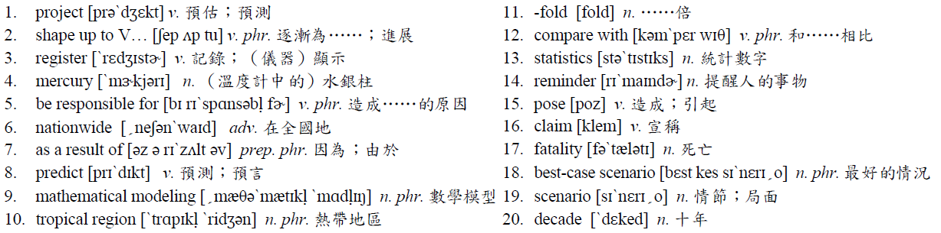
◆ Vocabulary and Idioms

◆ Patterns
The July heat wave in that city is believed to have been directly responsible for as many as 70 deaths.
= It is believed that the July wave in that city was directly responsible for as many as 70 deaths.
It is believed that + S + V的句型中，若主要子句中的動詞為過去式，用S + is believed… 改寫後，則動詞須以to have + p.p. 表示。
‧It is said that John has a lot of money.（據說John有很多錢。）
= John is said to have a lot of money.
‧It is said that John had a lot of money in the past.（據說John以前有很多錢。）
= John is said to have had a lot of money in the past.

◆ Translation

未來因熱浪喪生人數恐上升
近
幾年，熱浪已經變得愈來愈常見，而二○一八年逐漸為紀錄中最熱的一年。在世界的許多地方、城鎮和城市都記錄下了創紀錄的高溫。在七月二日，加拿大的第二大城蒙特婁的溫度飆升到攝氏36.6度，這是自約一百五十年前初次記錄以來，所記錄到的最高溫。人們相信在那城市七月份的熱浪，是直接造成高達七十人死亡的原因。而在南韓的首都首爾，八月初的溫度也已經到達他們一百多年以來的最高溫，達到攝氏39.6度。在全國，有近三十人因為熱浪而死亡。
根據最近的一項研究，研究人員預測到每一年因為熱浪而喪生的人數正逐漸增加。專家們使用數學模型，來製作一直到二○八○年的預測。根據他們的發現，在熱帶地區比較窮困的國家，和高溫有關的死亡人數，與一九七一年到二○二○年這個區段相較之下，在二○三一年到二○八○年之間，預計增加十二倍。更多的已開發地區，比如像是澳洲和美國，可能也會經歷高出五倍的死亡人數。這些驚人的統計數字僅是另一個提醒我們氣候變遷造成的危險罷了。
然而，仍然有希望。專家們宣稱，如果各國遵守巴黎協議中氣候變遷的政策，死亡人數將不會這麼高。但即使在最好的情況下，我們可以預見，與過去的五十年相比起，未來的幾十年中因熱浪所死亡的人數至少將會多出兩倍。

◆ Answer
(1) A (2) B (3) D

