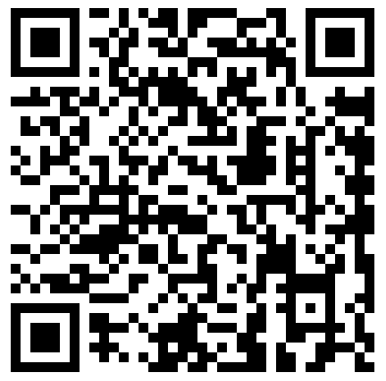
第 113期
龍騰文化全球資訊網：http://www.lungteng.com.tw
發行所：龍騰文化事業股份有限公司
地址：248新北市五股區五權七路1號
創刊日：2002年03月15日
出刊日：2015年10月01日
發行人：李枝昌
執行編輯：陳意君
電話：(02)2299-9063
傳真：(02)2299-9069
定價：10元
本刊物內容同步刊載於龍騰文化全球資訊網
1


作者：袁慧蘭

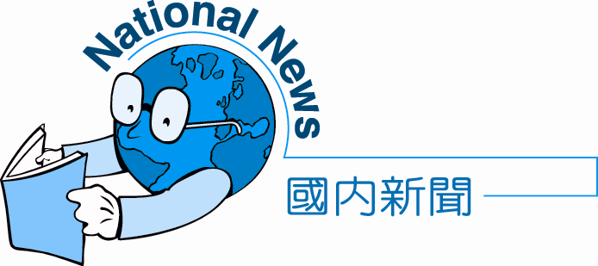

Cheers! Oktoberfest
Looking for some beer, music, and fun? Germany is the place to go. Every year in Munich, a beer festival (1) Oktoberfest is held. It is the world’s largest, (2) beer and wine festival. During the two-week party, people from all over the world (3) to Germany to take part in this wild extravaganza. (4) the beer, there are traditional events like outdoor concerts, parades, and costume parties that add to the fun.
In fact, this festival (5) the marriage of Prince Ludwig and Princess Therese, which took place on October 12, 1810. At that time, citizens were invited to celebrate the royal event by drinking beer and enjoying a horse race. The festival was so successful that it began to be held (6) . Gradually, the horse race was replaced with other forms of entertainment, such as a Ferris wheel and various (7) . However, the beer remained and became the festival’s most important attraction.
It is not difficult to imagine how exciting a beer festival would be in a place (8) beer is king. In 2014, the festival (9) roughly 6.3 million visitors, which was also how many liters of beer were consumed in two weeks. The event has (10) boosted tourism in Germany (10) prompted other countries to imitate it. Now there are beer festivals in Denmark, Norway, Sweden, as well as in North America and Asia. If you want to have a taste of the fun, choose one of those countries and start to beer up!

( ) 1. (A) regarded as (B) considered as (C) known as (D) seen as
( ) 2. (A) most famous (B) famous (C) more famous (D) the fame
( ) 3. (A) wander (B) flock (C) stroll (D) dash
( ) 4. (A) Furthermore (B) Because of (C) Whatever (D) Besides
( ) 5. (A) is limited to (B) is born into (C) dates back to (D) manages to
( ) 6. (A) additionally (B) annually (C) precisely (D) particularly
( ) 7. (A) competitions (B) contacts (C) contributions (D) combinations
( ) 8. (A) where (B) when (C) how (D) what
( ) 9. (A) distracted (B) disturbed (C) drew (D) decreased
( ) 10. (A) either; or (B) not only; but also (C) thanks; to (D) not; but
國 內 新 聞 National News

Editor’s Report
本期國內新聞為您帶來的是地表最盛大慶典之一「Cheers! Oktoberfest」慕尼黑啤酒節，娛樂新聞則是慕尼黑啤酒節的二三事「Welcome to Oktoberfest!」。瞄準新聞邀您一起以國際語言看新聞，也請您繼續給予我們鼓勵與支持。


1. Munich [ˈmjunɪk] n. 慕尼黑（城市名）  2. take part in 參與  3. extravaganza [ɪkˌstrævǝˈɡænzǝ] n. 盛大慶典  4. citizen [ˈsɪtǝzṇ] n. 市民  5. royal [ˈrɔɪəl] adj. 王室的  6. entertainment [ˌɛntɚˈtеnmǝnt] n. 娛樂  7. remain [rɪˈmеn] v. 留下  8. attraction [ǝˈtrækʃǝn] n. 賣點  9. roughly [ˈrʌflɪ] adv. 大約  10. liter [ˈlitɚ] n. 公升 | 11. consume [kǝnˈsjum] v. 吃，喝  12. boost [bust] v. 推動  13. prompt [prɑmpt] v. 促使  14. imitate [ˈɪmǝˌtеt] v. 仿效  15. Denmark [ˈdɛnmɑrk] n. 丹麥（國名）  16. Norway [ˈ nɔrwe] n. 挪威（國名）  17. Sweden [ˈswidṇ] n. 瑞典（國名）  18. taste [test] n. 體驗  19. beer up （諺語）暢飲

1. At that time, citizens were invited to celebrate the royal event by drinking beer and enjoying a horse race.
→ by + N/V-ing表示「藉著……」，其句型為S + V + … + by + N/V-ing…= By + N/V-ing…, S + V + ….。 例如：Jessica improves her English by listening to English songs.= By listening to English songs, Jessica improves her English.
2. Gradually, the horse race was replaced with other forms of entertainment, such as a Ferris wheel and various competitions.
→片語 replace with表「用……取代……」。若用主動的replace A with B，表「用B取代A」，例如：The basketball coach replaced the team captain with the youngest player on the team.。若以被動的A be replaced with B，則表示「A被B取代」，例如：The team captain was replaced with the youngest player on the team.

呼乾啦！慕尼黑啤酒節
想喝酒、聽音樂和玩樂嗎？德國正是你該去的地方。每年在慕尼黑都會舉辦一個慶典叫做「慕尼黑啤酒節」。它是全世界最大又最有名的啤酒慶典，而在這兩週的歡慶中，世界各地的人會湧入德國來參與此瘋狂盛大慶典。除了啤酒外，傳統的活動，像是戶外演唱會、遊行及化妝舞會皆為此慶典增添樂趣。
事實上，此慶典追溯至路德威希王子及泰瑞莎公主在1810年10月12日的婚禮。那時，當地的人民受邀一同慶祝此皇家盛會，他們喝著啤酒又欣賞著賽馬。也因為此慶典很成功，於是它就開始每年舉辦一次。漸漸地，賽馬被其他形式的娛樂，像是摩天輪及各種競賽給取代了。然而，啤酒仍保留而且成為此節慶中最重要的賣點。
在一個啤酒為王的地方，不難想像啤酒節會有多麼令人興奮。在2014年，啤酒節吸引了大約630萬觀光客，而這個數字也是兩週內所消耗的啤酒的公升數。此慶典不但推動了德國的觀光業，也促使世界各國起而效尤，例如丹麥、挪威、瑞典，還有北美及亞洲。如果你想體驗啤酒節的樂趣，選擇其中一個國家然後暢飲一番吧！
解答: 1.(C) 2.(A) 3.(B) 4.(D) 5.(C) 6.(B) 7.(A) 8.(A) 9.(C) 10.(B)
2
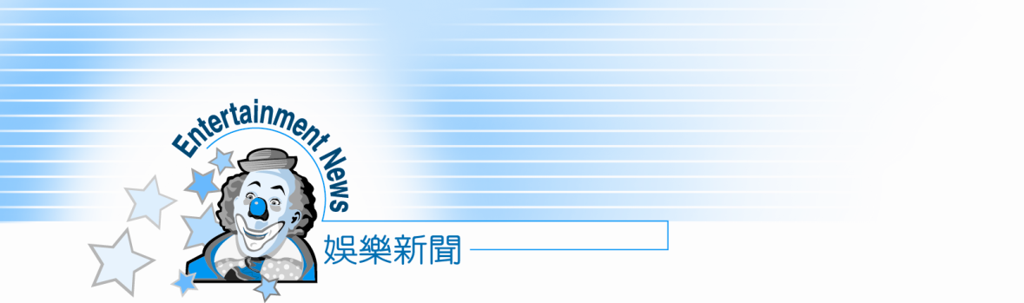

Welcome to Oktoberfest!
Receptionist: Guten tag. Thank you for calling the Oktoberfest information center in Germany. How may I help you?
Lisa: Hello. I am planning a trip to participate in Oktoberfest, and I have a few questions.
Receptionist: Sure. I’d be glad to answer them for you.
Lisa: When is the 2015 Oktoberfest, and once I’m in Munich, how can I reach the festival?
Receptionist: It begins on September 19, and it will last until October 4. Since there will be many visitors, I suggest you use public transportation such as the train or bus.
Lisa: Got it. And what is the number one must-see during the festival?
Receptionist: The opening ceremony is one of the most remarkable events. The mayor of Munich will tap the first keg of Oktoberfest beer, marking the beginning of the festival. Many people will come early in the morning just to witness this moment.
Lisa: Interesting. About booking hotels, I know they are especially expensive during that time. Are there any other options?
Receptionist: Of course. You can rent a tent and sleep in one of the campgrounds near the festival.
Lisa: Wow! Sounds cool. I will consider it. By the way, are children allowed at the festival?
Receptionist: Sure, and there are even family days that are planned especially for children. Of course, children love the rides and don’t care about the beer.
Lisa: I think you’ve answered all of my questions. Thank you very much!

3
娛 樂 新 聞 Entertainment News



1. Guten tag. 日安。（德文）  2. participate in 參加  3. reach [ritʃ] v. 抵達  4. last [læst] v. 持續  5. public transportation 大眾運輸  6. must-see [mʌst si] n. 必看之事  7. opening ceremony 開幕典禮  8. remarkable [rɪˈmɑrkǝbḷ] adj. 非凡的 | 9. mayor [ˈmеɚ] n. 市長  10. tap [tæp] v. 輕敲  11. keg [kɛɡ] n. 小桶（酒）  12. witness [ˈwɪtnɪs] v. 見證  13. option [ˈɑpʃǝn] n. 選擇  14. campground [ˈkæmpˌɡraᴜnd] n. 營地  15. consider [kǝnˈsɪdɚ] v. 考慮
歡迎來到慕尼黑啤酒節！
接待員 ：日安，謝謝你來電德國慕尼黑啤酒節遊客中心，有什麼需要服務的嗎？
Lisa ：你好，我正在計劃要去參加啤酒節，而我有一些問題。
接待員 ：請說，我很樂意回答你。
Lisa ：2015啤酒節是什麼時候？我到慕尼黑之後要怎麼去？
接待員 ：它從9月19日開始持續到10月4日。因為會有很多觀光客，我建議你使用像火車或公車等的大眾運輸。
Lisa ：了解，那什麼是啤酒節首要必看的呢？
接待員 ：開幕典禮是最不同凡響的活動之一，慕尼黑市長會打開第一桶啤酒節的啤酒來為慶典揭
（開序）幕。很多人為了要見證此刻很早就到場。
Lisa ：真有趣。那關於訂飯店，我知道這段期間的飯店都特別貴，有其他的選擇嗎？
接待員 ：當然，你可以租帳篷直接睡在靠近活動場地的露營區之一。
Lisa：哇，聽起來很酷，我會考慮。順便問一下，小孩子可以參加嗎？
接待員 ：是的，啤酒節甚至有特別為孩童設計的家庭日，但當然，比起啤酒，小孩子當然比較喜歡那些遊樂設施。
Lisa：我想你已回答我所有的問題了，非常感謝你！
飲酒過量，有礙健康。未成年請勿飲酒。
Excessive consumption of alcohol is harmful to your health. Drinking is prohibited for those under the age of 18.
4

