龍騰2016 *Book3L2 Handout 2* 名字: _____________ 角色:_______

*總得分*

**繳交序位得分**:____________

**團體蝸牛分數**:____________

**搭檔角色得分**:____________

**評出自己這張的認真指數**:☆☆☆

班級: ____________ 第______組 學伴: ______________ 角色:_______

學期成績計算方式: 1.段考60% 2.課堂表現30%(個人學習單+團體上台答題表現) 3.小考10% ***協同學習區(有固定學伴坐一起討論的，才可獲得搭檔角色分數喔~)***

***Pattern 句型語法辨識*** (請抄下單字例句中完整的部分。)

1. 從單字1~5例句中，找出1個「句子後半+…名詞子句」的句子，原句抄在後面

____________________________________________________________________________________

1. 從單字1~5例句中，找出1個「同位語」的句子，原句抄在後面

____________________________________________________________________________________

1. 從單字6~10例句中，找出1個「跟move有關的動詞片語」，把那個動詞片語抄在後面

____________________________________________________________________________________

1. 從單字6~10例句中，找出1個「it be adj. that + 名詞子句」的句子，原句抄在後面

____________________________________________________________________________________

1. 從單字6~10例句中，找出1個「被動語態」，原句抄在後面

____________________________________________________________________________________

1. 從單字11~15例句中，找出1個「形容詞子句」，原句抄在後面

____________________________________________________________________________________

1. 從單字16~18例句中，找出1個「形容詞子句」，原句抄在後面

____________________________________________________________________________________

**Phrases 圈詞，並且填空**

1. **make use of** 利用● The students **made use of** plastic bottles to create a beautiful Christmas tree.

學生們利用塑膠瓶創作了一棵美麗的耶誕樹。**\*是__VP___片語，使用位置是_前面 +S，後面 ＋Ｏ**

2. **think of** 想出 ● How many ways can you **think of** to save energy in your house?

你能想出幾種在家中節約能源的方法？ **\*是_________片語，使用位置是_____________________**

3. **take a look at** 瞧一瞧● You can find many modernist① paintings in the museum. Remember to **take a look at** them when you go there.博物館裡有很多現代主義的畫作。記得到那裡時一定要去瞧一瞧。**\*是_________片語，使用位置是_____________________**

4. **now that** 既然● I think we should forgive the boy **now that** he has learned his lesson.

既然那男孩已經得到教訓，我想我們應該原諒他。**\*是_________片語，使用位置是_____________________**

5. **happen to** 恰好；剛好● The coming Lunar New Year’s Day **happens to** be Valentine’s Day. Why don’t we celebrate② this special holiday in both Eastern and Western ways?今年的農曆春節恰好是西洋情人節。我們何不用東方和西方兩種方式來慶祝這個特別的節日呢？**\*是_________片語，使用位置是_____________________**

6. **care about** 關心● My homeroom teacher not only pushes us to study but also **cares about** our health.

我們導師不僅督促我們讀書，還關心我們的健康。**\*是_________片語，使用位置是_____________________**

7. **be good at** 擅長● Simon **is good at** playing football. He wants to be like David Beckham when he grows up.

Simon很擅長踢足球。他將來長大想和大衛‧貝克漢一樣。**\*是_________片語，使用位置是_____________________**

1. **right away** 立刻● Grandpa fell off the chair just now and hurt himself badly. We need to take him to the hospital **right away**.爺爺剛剛從椅子上摔下來受傷嚴重，我們必須立刻送他去醫院。**\*是_________片語，使用位置是_____________________**

單字聯想題

找出下面圖片的聯想單字(單字一定是單字表中的!)

_________________________ _________________________ _________________________



_________________________ _________________________ ___________________

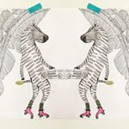

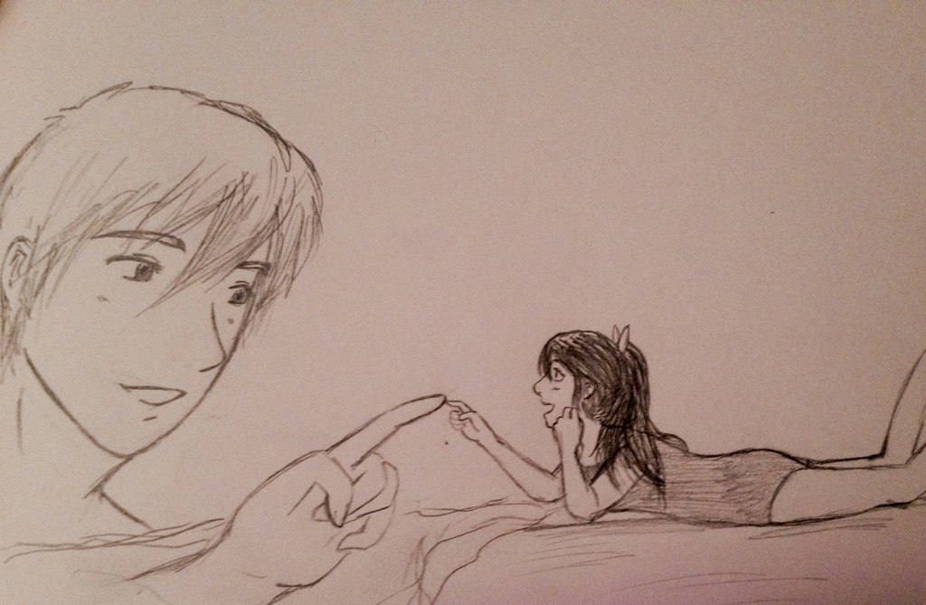



翻至pg. 2，People around the world have rather different eating customs. Refer to Pg. 2 and dig out facts on worldly eating customs. Below are 5 questions for you. 先將題目中的They改成People in (which country)~~~並將整句中文翻譯如下，第一題已做好給你了。第5題句型轉換了，注意變化。

第1題 : **People in Taiwan** do not stick chopsticks into the rice bowl straight up.

台灣人不將筷子直插入碗中。______________________________

第2題 : _People in ( ) don’t… _________________________________________________(英文句子)

_____________________________________________________________________(中文翻譯)

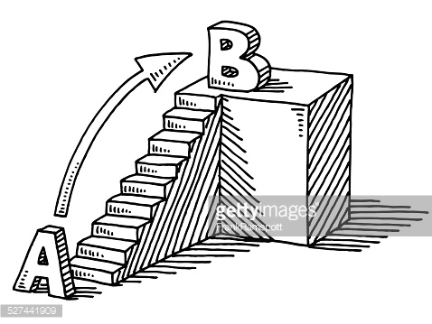

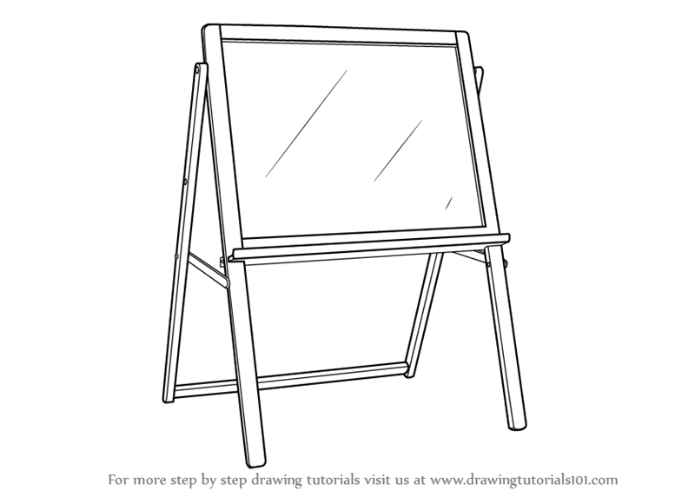



第3題 : _People in ( ) created… ________________________________________________(英文句子)

_____________________________________________________________________(中文翻譯)

第4題 : _People in ( ) eat… ___________________________________________________(英文句子)

_____________________________________________________________________(中文翻譯)

第5題 : _People in ( ) enjoy… _________________________________________________(英文句