龍騰2015 Book4L6 Handout 3閱讀策略 (請於上課前完成90%，每題目只有1-2分鐘，為小組討論與練習念的時間，其他為全班開放式討論、各組互評或蝸牛區搶答時間)。最後3分鐘為教師歸納統整時間。
總得分
正確率分數: ______________

蝸牛搶分區: ______________
實際花費分鐘數: ___________min.
自己的名字: _______________ 組別(1~12)是 _______________
(自己統計) (老師統計)
自學分數: __________________ 實際花費分鐘數: ______________min.
自學、共學區(根據課本與提供的資料，思考出最合理的答案~)
*** (待會兒報告互評時間)被抽到報告的組別，只要成功上台報告，直接拿10分到30分，老師追問的問題，若是其他組可以補答，在蝸牛區每次得5分。
蝸蝸討論時間2分鐘。 Background Knowledge (讀完下段，理解內容，提問跟內容有關)
(1)摘要實戰: 請「只用四句中文話」講完(摘要)下面這個故事。注意，「只用四句中文話」。互評1
Greatly inspired by the story of Mazu, Jack made it a rule to do at least one good deed on a daily basis. One day Jack came upon a Big Lotto ticket worth two billion dollars during his litter-picking routine. Without a second thought, he handed it over to the police. The owner, more than excited about the recovery, expressed his gratitude by rewarding him generously. The good deed thus earned Jack the title of “Pride of the School.”
- _____________________________________________________ 2. _______________________________________________________
- _____________________________________________________ 4. _______________________________________________________

(2)馬祖與澳門地名的由來
清初《使琉球記》中記載，媽祖二十八歲時因父兄駕船駛至閩江口海域，遇風浪船毀人溺，媽祖為救父兄入海罹難，她的遺體當年隨海漂至閩江口附近的小島（即今日馬祖列島的南竿島），為漁民打撈上岸，並將她葬在岸邊。湄洲島的鄉親一度以為默娘失蹤沒下落，故稱她已羽化升天成仙，且為感念其孝心，遂蓋廟紀念她的孝行。經後代學者查知，媽祖葬於現今馬祖南竿鄉馬祖天后宮內靈穴石棺中，且興廟供奉媽祖世代相傳至今，成為馬祖居民最重要的信仰之一。此島因而稱為媽祖島，爾後中華民國國軍進駐為顯陽剛之氣，去掉女字旁改稱馬祖島，馬祖之名遂使用至今。
媽祖廟在澳門稱為「媽閣廟」，澳門民間流傳一種說法：「先有媽閣廟，後有澳門城」，可見媽閣廟歷史悠久。四百多年前，葡萄牙人從媽閣廟附近上岸後，問當地居民：「這是什麼地方？」因語言不通，當地人回答說這裡是「媽閣」。葡人誤以為「媽閣」就是這裡的地名， 於是葡人把「媽閣」稱為「Macau」，譯成中文就是「澳門」，這一歷史性的誤會一直沿用至今。值得一提的是：澳門媽閣廟在2005年被UNESCO列入「世界文化遺產」名錄內。
蝸蝸
(3)和臺灣媽祖信仰相關的祭祀活動如下：
(1) 迎媽祖
甲鎮瀾宮以往每年在媽祖生日前則舉辦「大甲媽祖回娘家」的活動，讓信眾步行跟隨著媽祖神轎，從大甲一直往南走到北港。該活動參加者動輒十數萬人，可說是在臺灣僅見的最大規模宗教活動。近年來改往新港奉天宮進香遶境出巡，路程更遠，人數卻更多。
至於北港朝天宮的「迎媽祖」，其熱鬧場面也與大甲媽祖出巡不相上下。每年開春之後，各地到北港拜媽祖的信眾便絡繹不絕。到了誕辰當天，湧進北港的信眾，更有如浪濤洶湧般，鎮日鑼鼓喧天，熱鬧的程度甚至到瘋狂的地步。
所謂的「迎媽祖」，是到外地去迎一尊本地居民普遍信仰或有淵源的媽祖來參與巡境的活動。不管自己村裡或是共同舉行迎媽祖的區域是否已有一尊「在莊媽」或「在地媽」，都可能會往外地去迎媽祖。通常是往地域層級高一點的地方去迎媽祖。蝸
(2) 進香
「進香」是到遠處的、有名的、歷史悠久的、香火旺盛的寺廟去朝香，表示對該神明的敬意。與迎媽祖的差別是進香並不會把對方的媽祖之神像請回來，只是去分沾她的香火，因此自己的神明是要出去的。到了進香對象的媽祖廟，神像也要進去，放在神殿上，有時是用「掬火」的方式，有時是用交香的方式，沾取對方的香火。另一個與迎媽祖的差別是進香的地點不一定與地域層級有關，因此進香的地點遠一點也是常見的事。蝸
(3) 遶境 蝸
「遶境」指神明對轄境之區域進行遶境清理及巡視。如每年元宵節晚，於大甲鎮瀾宮內，擲筊決定大甲媽祖遶境進香時程。
課文脈絡學習區
Paragraph 1互評2  1.1. Mazu is believed to be the goddness of the sea by some Taiwanese. Who is the Greek goddness of the sea?  The Greek __________________________is _______________  1.2 Which continent are most Mazu temples located in?  *Most Mazu temples are _____________________________  Paragraph 2  2.1 What dynasty was Mazu born in?  *Mazu was born in ___________________________________  2.2 What did people see when Mazu was born?  _People saw _________________________________________  2.3 Why was Mazu’s original name Mo-niang, which means “silent” in Chinese?互評3  *Mazu, as a baby, did _________________________________  2.4 Why did the author think Mo-niang was a exceptional child? Mo-niang often … ___________________________________________________  2.5 What was Mo-niang’s supernatural power? She had the ability _____________________________________________  2.6 How did Mo-niang get her supernatual powers? ___________________________________________________  Paragraph 3 互評4  - What happened when Mo-niang was 21 years old?  ___________________________________________  - How did Mo-niang save all the farmers and their crops? She ________________________________  ___________________________________________  - What happened when Mo-niang was 28 years old?  _Mo-niang __________________________________  ___________________________________________.  - According to a legend, what emperor of China was saved by Mazu  ___________________________________________  互評5  - What is a “legend”? Please explain in English.  _A legend is …_______________________________  ___________________________________________. | 4.2 What is a “heritage”? Explain in English.  A heartage is …____________________________________  ________________________________________________  - Think of a god or goddess which shares similar legends or stories? And explain why.  A simiar god/goddess is ____________________________  because _________________________________________  ________________________________________________  文化比較題 Compare and Contrast  *Compare the two picures of goddesses. One is Mazu, the other is a Greek goddess. Make compare and contrast.  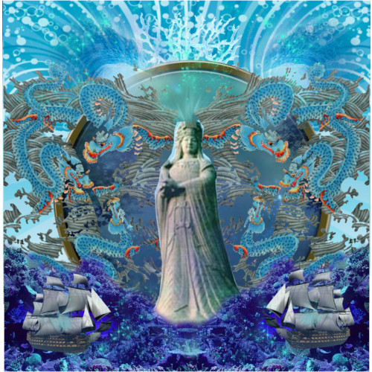  They are similar because …  - __________________________________________  - __________________________________________  - __________________________________________  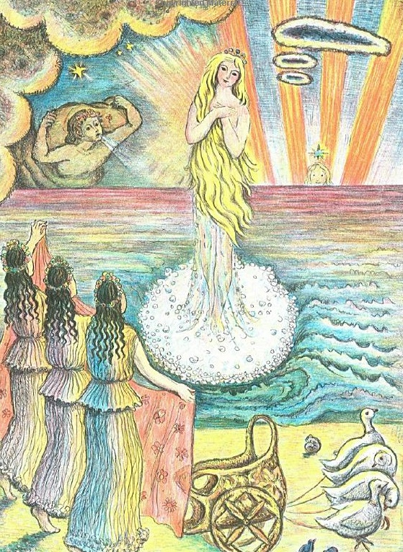  *They are quite different because…  4. _____________________________________________  5. _____________________________________________  6.______________________________________________

