Coronavirus¹: The Story So Far

Coronavirus Causes and Symptoms²

The novel coronavirus that emerged³ in China late last year causes a medical condition in humans called COVID-19. This condition was first detected⁴ in several patients in Wuhan; thus, it is sometimes referred⁵ to as the Wuhan coronavirus. COVID-19 can be passed among humans. In addition, although people with the condition may exhibit⁶ no symptoms for up to 14 days or perhaps even longer, during this symptomless period, the virus can still be given to others. Together, these factors have enabled COVID-19 to spread rapidly.
Coronaviruses can cause a wide range of illnesses in humans, from mild⁷ conditions such as colds to far more severe⁸ ones. These viruses develop in animals before being passed on to humans. The virus that has led to COVID-19 is thought to have come from Wuhan’s Huanan Seafood Wholesale⁹ Market, a market where many types of meat and living animals were being sold.
Coronaviruses attack the human respiratory¹⁰ system, which is responsible for breathing. Therefore, common symptoms of COVID-19 include coughing and difficulty breathing, as well as fever in many cases.

Further Suggestions¹¹ for Disease Prevention¹²

In addition to frequent¹³ hand washing, there are a number of other measures¹⁴ you can adopt to reduce your chances of becoming infected¹⁵ with the coronavirus. For example, when you cough or sneeze¹⁶, cover your nose and mouth with your arm or with a tissue. If you use a tissue, be sure to throw it away immediately after use and then wash your hands.
Another measure is to physically distance yourself from other people, especially those who exhibit symptoms of COVID-19. Also, try to touch your face as little as possible. This measure is advised because the coronavirus can easily be spread through contact between people’s hands and objects carrying the virus. Not touching your face could prevent you from becoming infected. Finally, if you begin to display any symptoms of COVID-19, be sure to seek medical help as early as possible. Earlier detection¹⁷ of the disease could enable you to make a quicker recovery¹⁸ and prevent those around you from becoming infected.

Word Bank

1. coronavirus [kə`ronəˏvaɪrəs] n. 冠狀病毒  2. symptom [`sɪmptəm] n. 症狀  3. emerge [ɪ`mɝdʒ] v. 出現  4. detect [dɪ`tɛkt] v. 察覺；查出  5. refer [rɪ`fɝ] v. 談到；提及  6. exhibit [ɪg`zɪbɪt] v. 顯現出  7. mild [maɪld] adj. 輕微的；溫和的  8. severe [sə`vɪr] adj. 嚴重的  9. wholesale [`holˏsel] adj. 批發的 | 10. respiratory [rɪ`spaɪrəˏtorɪ] adj. 呼吸的  11. suggestion [sə`dʒɛstʃən] n. 建議  12. prevention [prɪ`vɛnʃən] n. 預防；防止  13. frequent [`frikwənt] adj. 頻繁的  14. measure [`mɛʒɚ] n. 措施  15. infected [ɪn`fɛktɪd] adj. 被傳染的  16. sneeze [sniz] v. 打噴嚏  17. detection [dɪ`tɛkʃən] n. 發現  18. recovery [rɪ`kʌvərɪ] n. 痊癒

譯文

冠狀病毒疫情：目前為止的情況

冠狀病毒的原因和症狀
去年年底在中國出現的新型冠狀病毒會導致人類患上一種稱為COVID-19的疾病。該病首次在武漢的幾名病患身上被發現；因此，它有時又稱為武漢冠狀病毒。COVID-19可以在人類之間傳染。此外，雖然患有這種疾病的人在長達14天或更長的時間內可能沒有顯現出症狀，但在此無症狀期間，這株病毒仍然可以傳播給其他人。這些因素綜合在一起使得COVID-19得以迅速傳播。
冠狀病毒會引起多種人類疾病，從像是感冒的輕症到更為嚴重的病。這些病毒在傳播至人類之前先在動物體內發展。導致COVID-19的這株病毒被認為來自武漢市的華南海鮮批發市場，該市場出售許多種的肉類和活體動物。冠狀病毒攻擊人類的呼吸系統，該系統主管呼吸。因此，在許多的病例中， COVID-19的常見症狀包括咳嗽、呼吸困難，以及發燒。

預防疾病的進一步建議
除了經常洗手之外，你還可以採取一些其他方法來減少你感染冠狀病毒的機會。例如，當咳嗽或打噴嚏時，用你的手臂或衛生紙遮住你的鼻子和嘴巴。如果使用衛生紙，確保在使用後立即將其丟棄，然後洗手。
另一個方法是與其他人保持身體距離，特別是那些顯現COVID-19症狀的人。此外，盡可能少碰觸你的臉。建議這個方法是因為冠狀病毒很容易透過人們的手接觸攜帶該病毒的物體而傳播。不觸摸臉部可以防止你受感染。最後，如果你開始顯現COVID-19的任何症狀，務必盡早尋求醫療幫助。提早發現該疾病可以使你更快地康復，並防止你周圍的人被傳染。

素養題
- ( ) Which of the following map shows the origin of the virus that has led to COVID-19?
 | 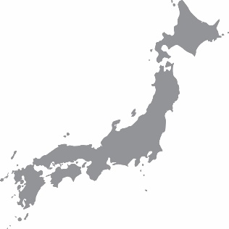
(A) | (B) | (C) | (D)

- ( ) Which of the following is NOT mentioned as a symptom of COVID-19 ?
(A) Sneezing (B) Bleeding (C) Coughing (D) Fever

- ( ) Liz travelled to South Korea during winter
vacation and went back to Miaoli on Feb. 9, 2020. According to the law, Liz had to stay home for a period of time and could not go anywhere. When was Liz able to go back to school?

(A) Feb. 20 (B) Feb. 22 (C) Feb. 29 (D) Feb. 24

- ( ) According to the article, coronaviruses attack which part of the body?
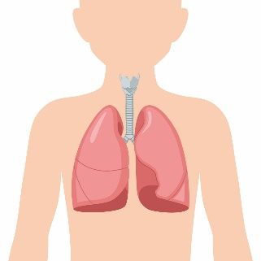 | 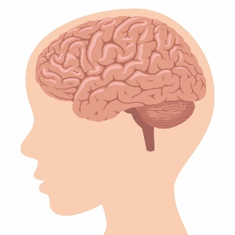 | 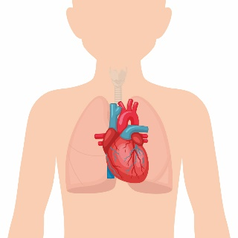 | 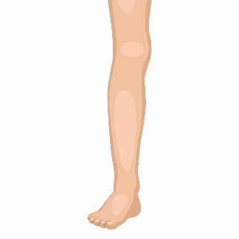
(A) | (B) | (C) | (D)

Clinton works in the public health center in Taichung. After the outbreak of COVID-19, the government asked Clinton’s team to design a poster to educate local people about how to protect themselves from COVID-19.

- ( ) Which of the following would be the best slogan for the poster?
(A) An apple a day keeps the doctor away.
(B) Don’t wash your hands.
(C) Wild animals are delicious and nutritious.
(D) Don’t touch your face.

- ( ) Which of the following might be a poster Clinton’s team designed?
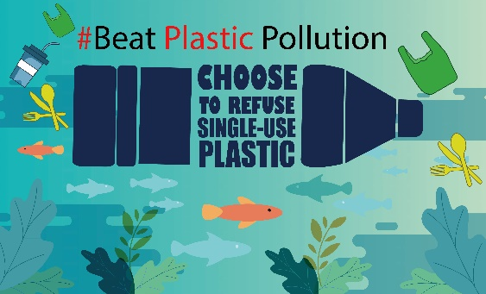 | 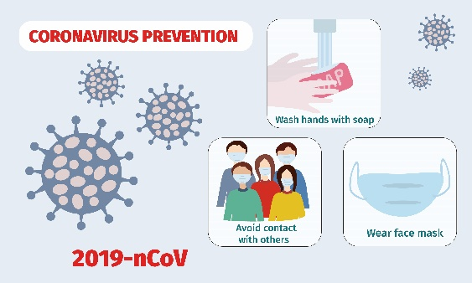
(A) | (B)
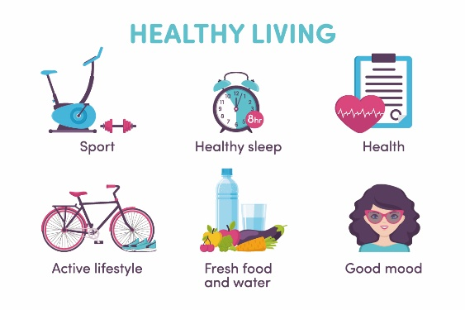 | 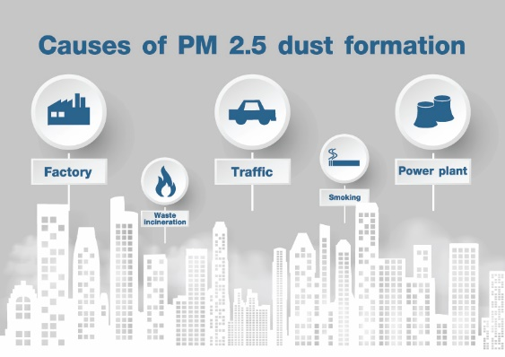
(C) | (D)

解答：
1. (C) 2. (B) 3. (D) 4. (A) 5. (D) 6. (B)

